**Website Hosted On Github Link:**

<https://andrewplum.github.io/CS_360/Labs/Lab_3/UI_Website_Home.html>

1 UI_Website_Home.html:

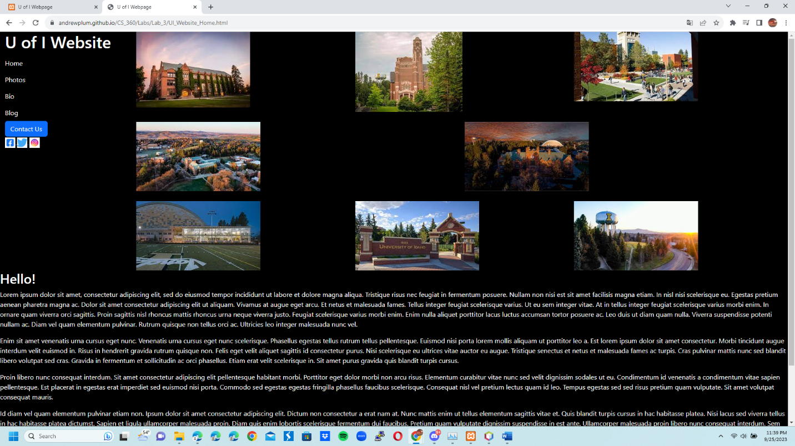

2 UI_Website_Photos.html: 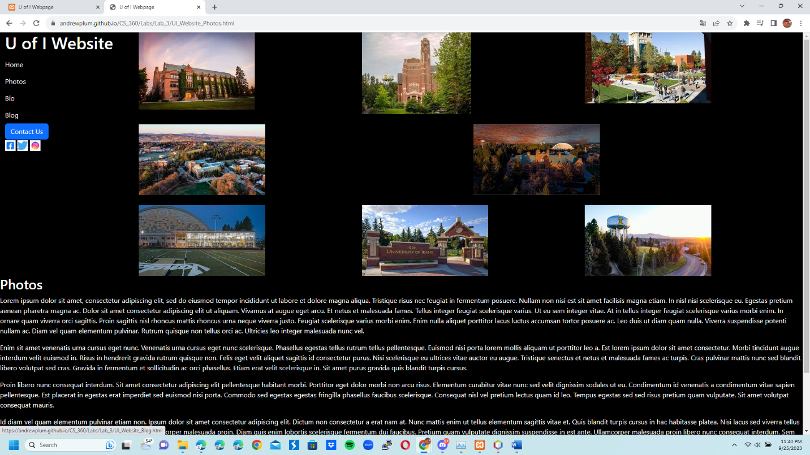

3 UI_Website_Bio.html:

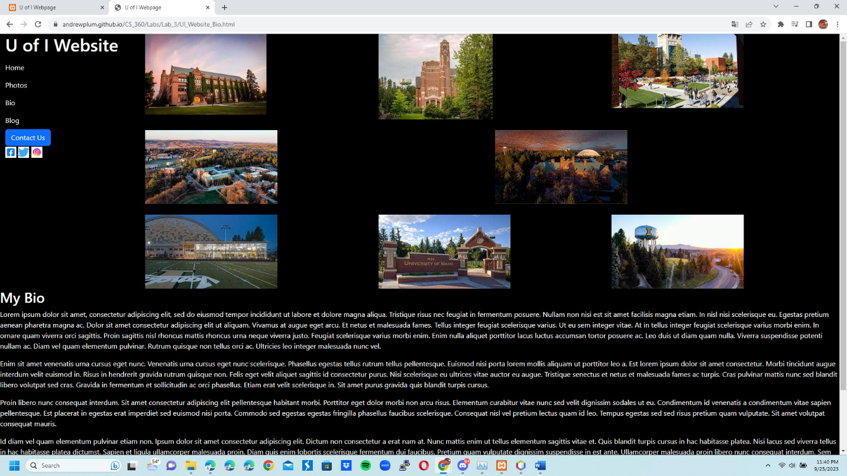

4 UI_Website_Blog.html:

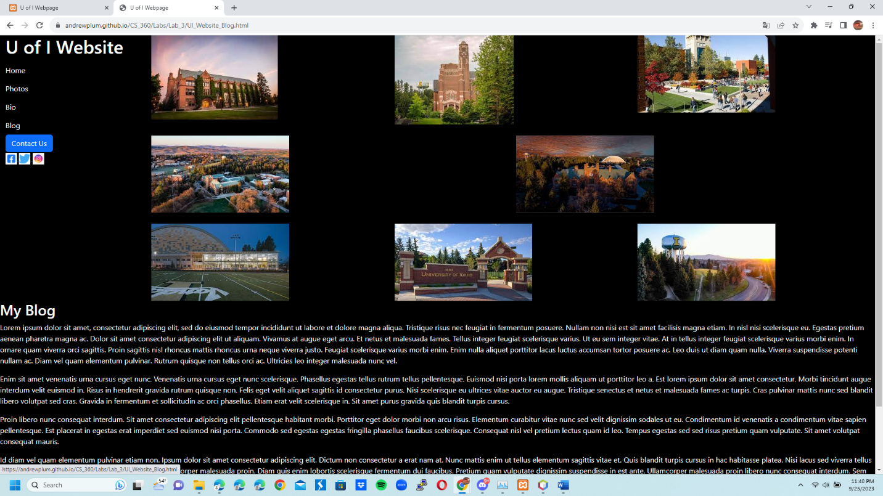

5 UI_Website Contact Us:

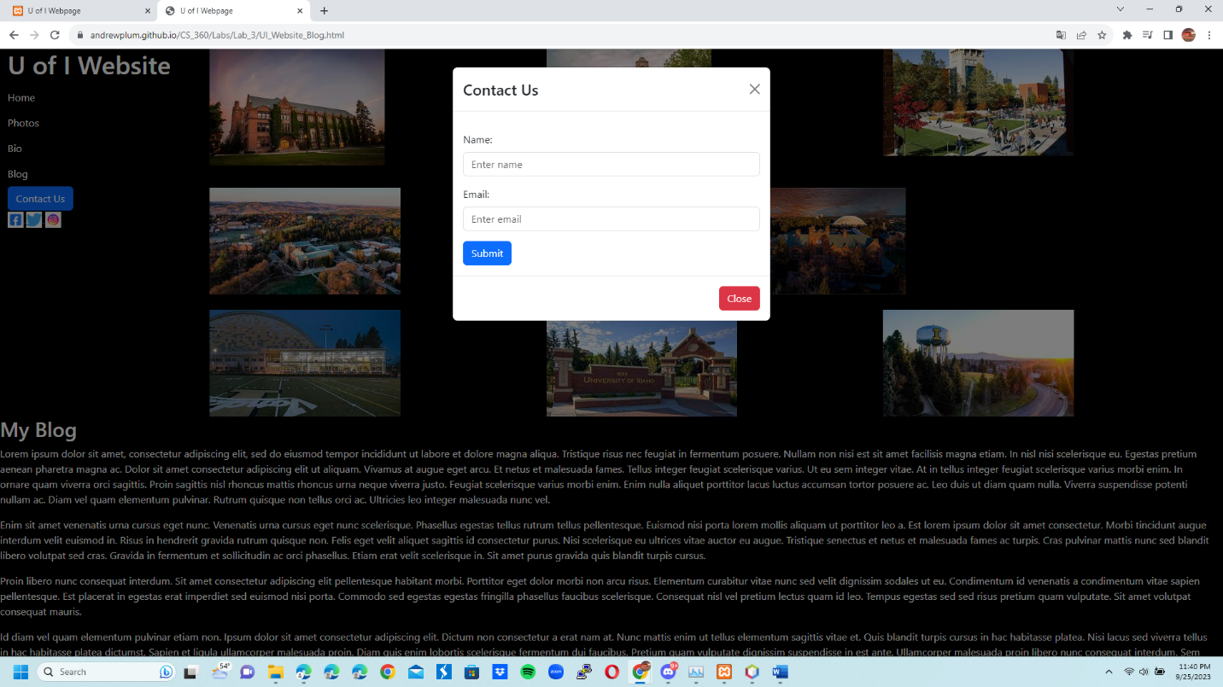

6 UI_Website Picture 1:

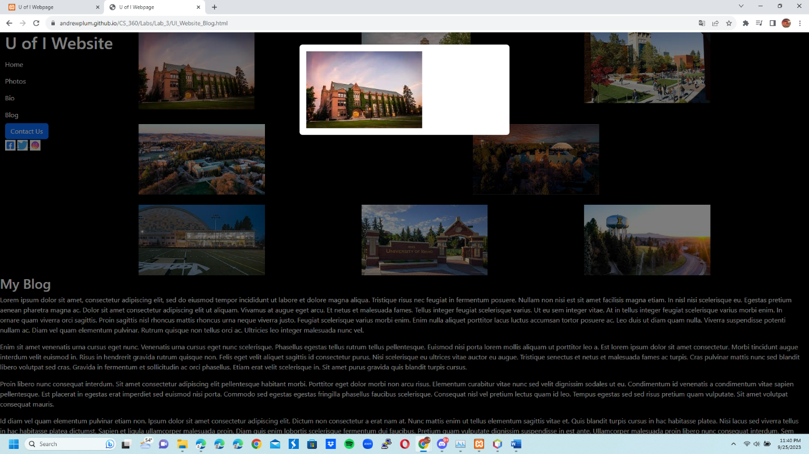

7 UI_Website Picture 8:

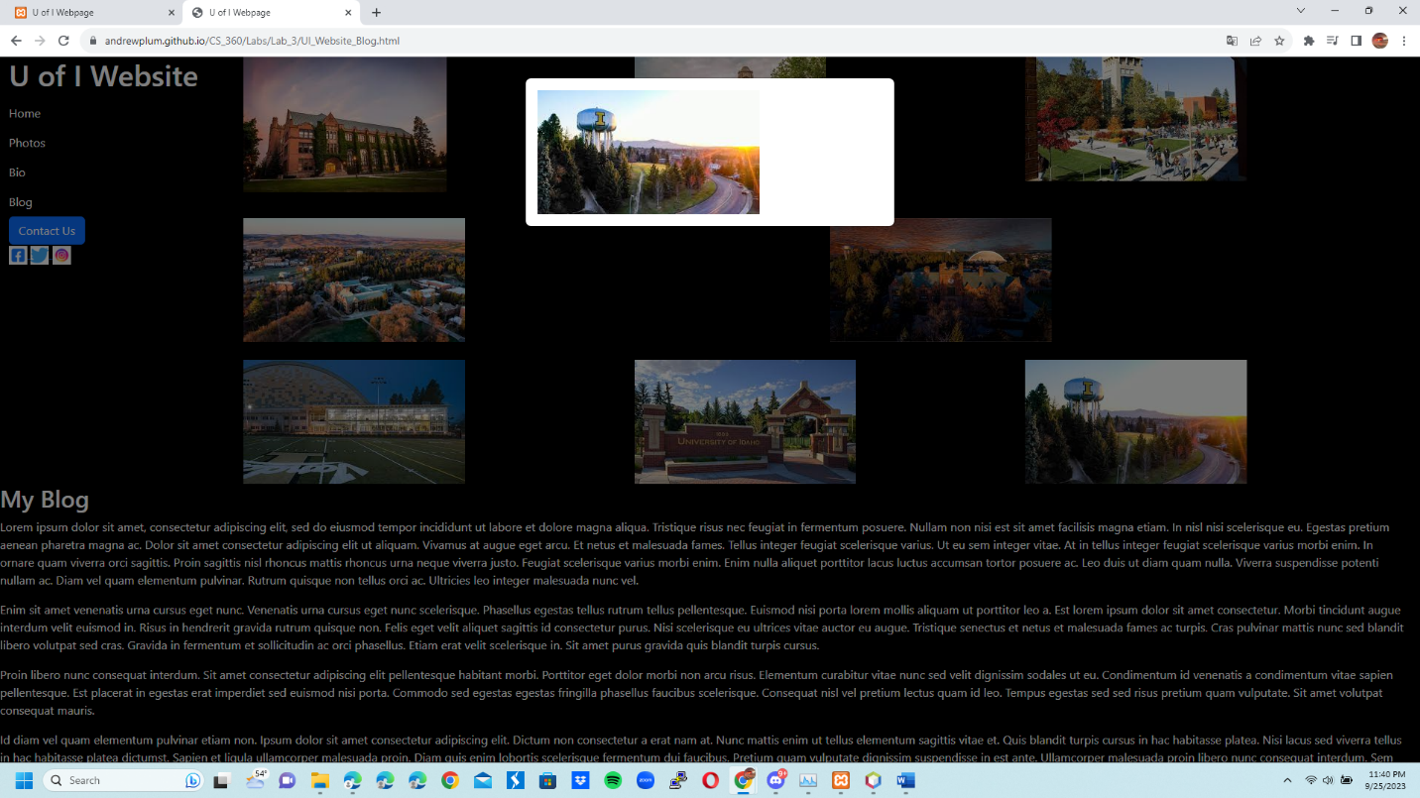

**Website Hosted On Github Link:**

<https://andrewplum.github.io/CS_360/Labs/Lab_3/UI_Website_Home.html>